
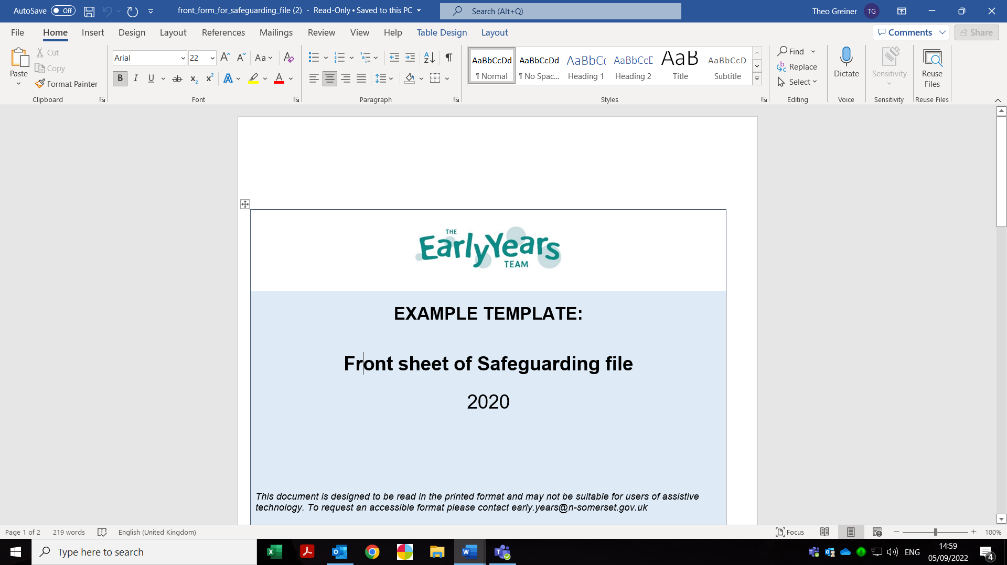
Record of Concern
Log number |  | Name of Person completing this form
 |  | Signature
 |  | Role
 |  | Date and time form completed
 |  | Please tick if the details of the person recording the concern are the same as the person reporting *

PART ONE
Child’s name: ………………………………………………Date of incident…………

D.O.B. ………………………………………………………Time of incident………

Factual Description: (What are you worried about? Are there any witnesses? If recording a verbal disclosure from a child use their words, record if a body map has been used, * if you have been made aware of a concern from another person include their details including contact details)
Child’s voice
Parent/Carer’s comments:(If information not shared with parent/Carers, record reason why)

Parent/Carer’s name
signature and date
DSL name
DSL Signature, date and time of receiving part one
PART TWO – Response to the incident/concern, to be completed by the DSL
Action plan: (What needs to happen? Monitoring/ seek advice/early help/referral to children’s social care?)
Action taken: (include names of anyone to whom information was shared with times and dates)
Outcome: (detail below outcomes of the actions taken)
I consent to information sharing and that the information on this sheet, to the best of my knowledge, is factually correct.
(If consent not sought, please give reasons here)
Signed Parent/Carer: …………………………………….. Date and time …………..
Signed DSL: ……………………………………………… Date and time …………..

