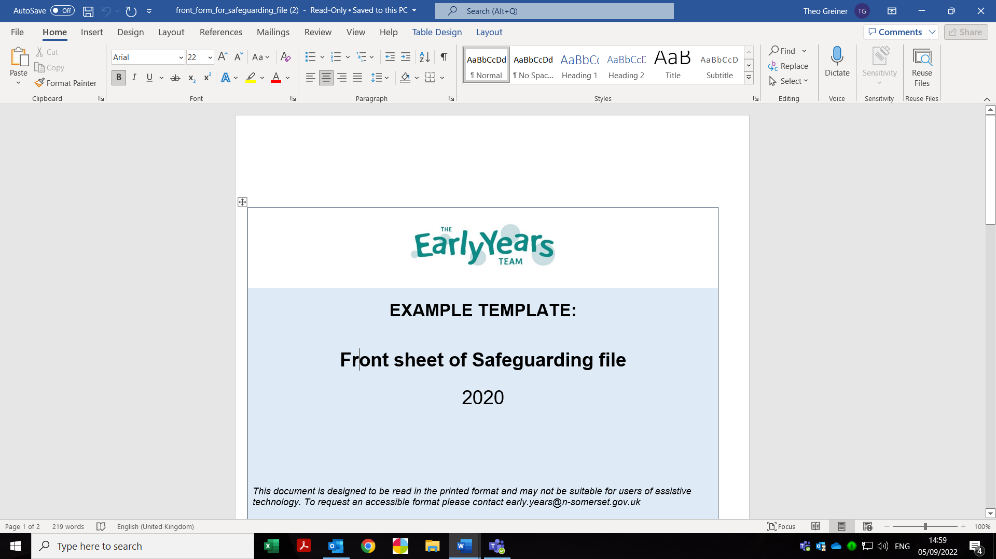

Monthly safeguarding audit of information/ record of concern forms
Month
No | Name | Date | Information  recorded by | Information passed onto | Cause for concern/information  - any outstanding actions | Key  person | Deputy Manager | Nursery manager
1
2
3
4
5

