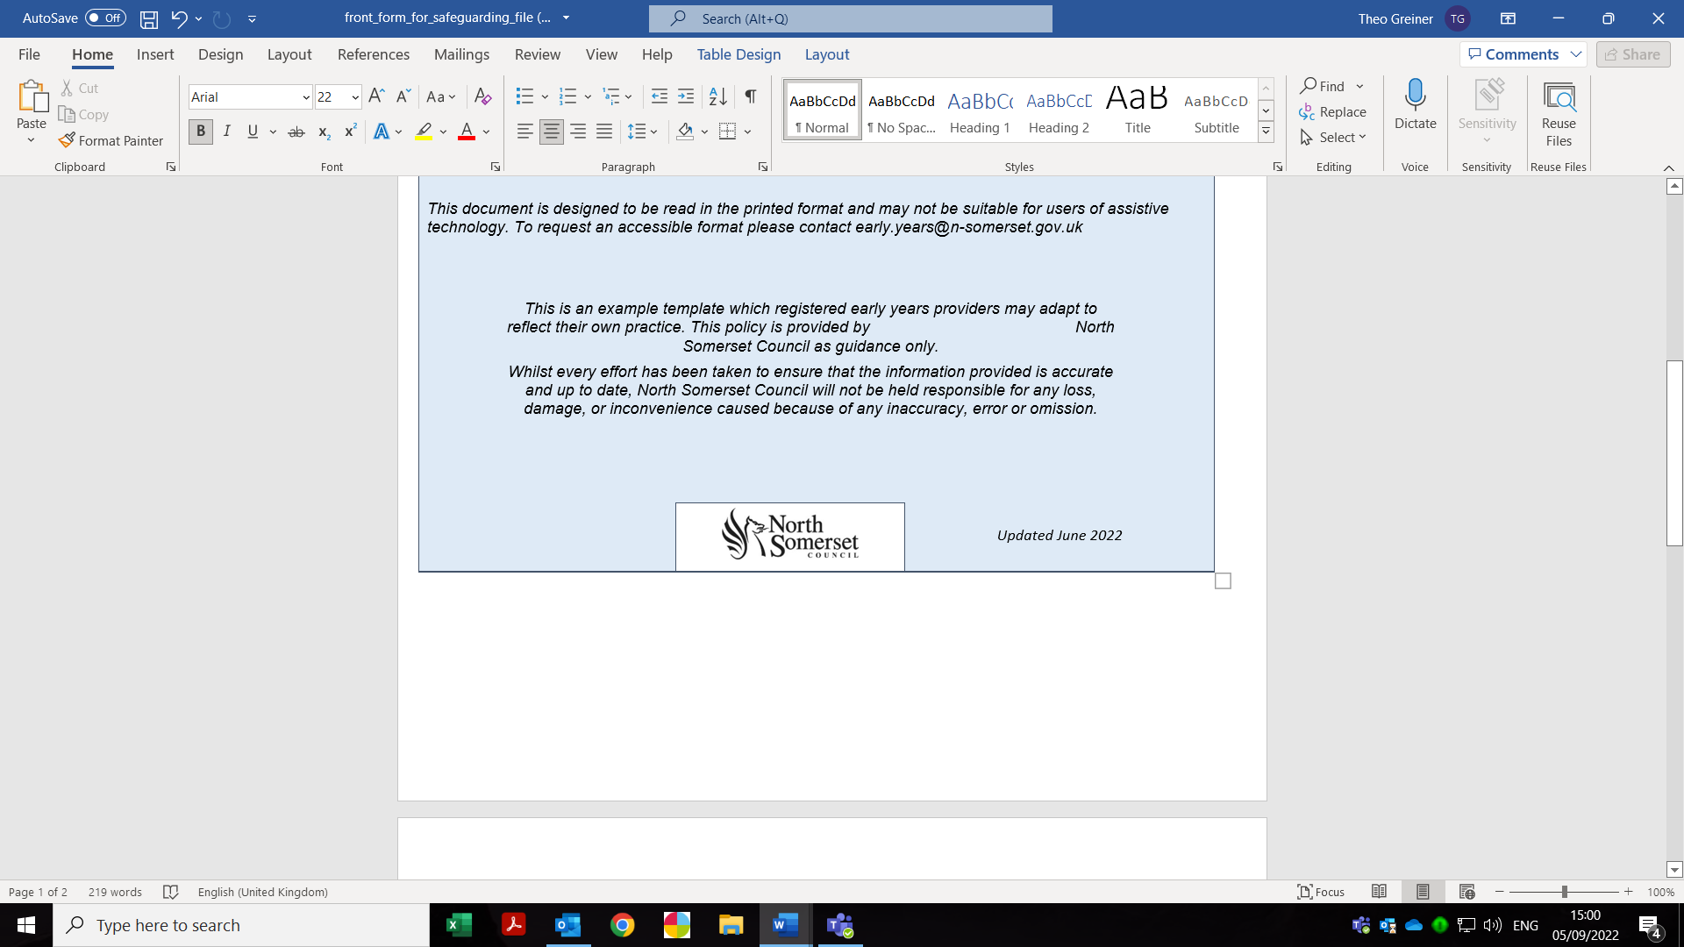
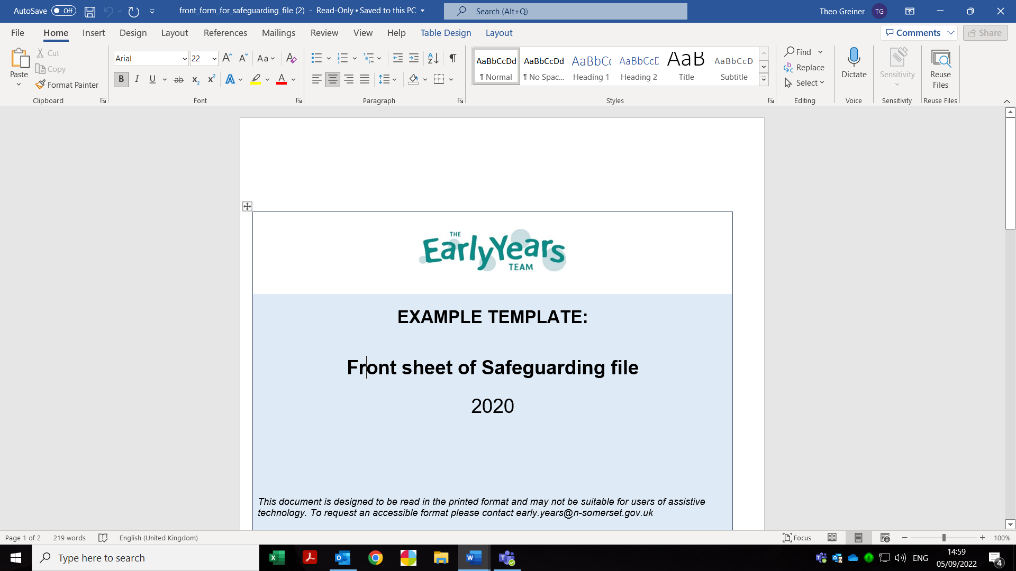
Front sheet of safeguarding folder
Child’s name |  | Date of birth
Date file started |  | Any other name/s by which the child is known by
Home address |  | Current address (if different)
Home telephone number |  | Current telephone number (if different

Family members, parents, step-parents, carers
Name | Relationship to child | Address | Parental responsibility for the child enter Y/N

Family members, siblings
Name | Address | Educational establishment
Are records held in the setting relating to other connected children Y/N
If yes, which files are relevant

Contact details of other professionals
Name | Agency | Contact details (email, phone)

