|  |  |  |
| --- | --- | --- |
| **North Somerset Early Help: Let's Talk Tool**  Child(ren)'s name(s) and pronouns: Parent(s) or carer's name and pronouns: | **What's working well?**  This is where you record the good stuff! What do you/your family enjoy? Think about what you feel good about and the things that make you happy. What kind of support are you already benefitting from? | **What are we worried about?**  Think about what's important to you and your family. This is where we record your concerns and what we have identified as a concern. What do you think could be better? What have you tried already? |
| **Family and environmental factors**  Who lives at home with you? Do you get on well?  Are there people around that can help when you need it?  Is there anyone in the family that needs extra help or support? Has anyone you know been in trouble with the police recently? Do you ever worry that they might be?  Are there any worries around substance use? |  |  |
| **Basic safety and protection**  What's good about being at home? Is there anything that could  make you feel happier there?  Do you feel safe at home and with the people you spend time with? Do you feel well-supported and confident to meet the needs of everyone in the household? |  |  |
| **Developmental, physical and mental health**  Do you feel well in yourself? Have you been to the doctors for  anything recently?  Do you have friends you're close with? Can you tell me about them?  Do you ever feel especially low or worried?  Do you or your child have special educational or additional needs,  and are these being supported in a way that works for you?  Have you noticed anyone in the family being over or under sensitive  to light, noise, smells, taste, touch, or other senses?  Do you notice any differences between how your child speaks, learns  or acts, compared to other children their age? |  |  |
| **Learning and education**  Have there been any problems at school? If there were, did you feel  well-supported to deal with them?  Do you go to school and/or work? How do you find it?  What do you enjoy/feel you're good at?  Do you get any extra support to help you learn? Has it been helpful? Do you feel like you have everything you need to support learning or playing together at home? |  |  |
| **Housing and finance**  What's your home like? What do you like about it? Is there anything  you wish was different?  Do you feel safe where you live?  Are there people in the family who work? What kind of work do they  do?  Are there any worries around paying for food or bills? |  |  |

If you need guidance about how to use this tool to have a coversation with the family/child and how to plan the next steps, read the Early Help Strategy. ***The questions provided under each***

***headings are prompts only - you do not need to ask every one and they should be adapted according to who you're talking to and what the main worries are.***

# North Somerset Early Help Continuum of Need Tool

ils about

will help you

**secti ons**

**re**

Basic care, safety, and protection

Learning and education

Housing and

finance

Developmental physical, and mental health

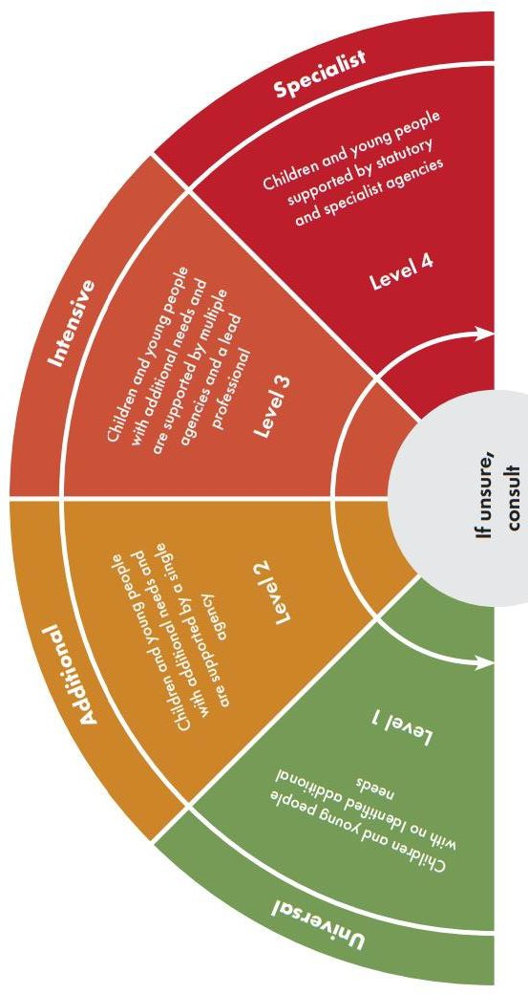This tool should be used alongside *Effective Support for Children, Young People, and Families,* which provides more deta the levels of need and what you should do at each level*.* The responses to the questions in the Early Help Let's Talk Tool place the child or family on the Continuum of Need.

**Your response should be informed by the highest level of need. For instance, if the response is additional for 4 of the below, intensive for 1, then the overall level of need should be deemed intensive. Read the *Early Help Strategy* for mo guidance.**

Family and environmental factors

|  |  |  |  |  |  |  |
| --- | --- | --- | --- | --- | --- | --- |
| **Universal** |  | **Additional** |  | **Intensive** |  | **Specialist** |
| Stable relationships with caregivers, siblings, peers and age-appropriate friendships |  | Parents/Carers have relationship difficulties or there is frequent conflict which may affect the child |  | Risk of family relationship breakdown leading to need for child to become looked after outside of family network |  | Adults who present a risk  to children living in the  home. Family characterised by conflict and chronic relationship  difficulties |

|  |  |  |  |  |  |  |
| --- | --- | --- | --- | --- | --- | --- |
| Parents/Carers provide care for (unborn) child’s needs and protect from danger in the womb, home, and elsewhere |  | Requiring advice/support on safe and appropriate childcare arrangements and safe home conditions |  | Parents/carers unable to protect from danger or significant physical or emotional harm in the home and elsewhere |  | Parents unable to provide adequate and safe parenting and child is immediately at risk of abusive situations |
|  |  |  |  |  |  |  |
| Health appointments, including antenatal, are kept and advice given is acted upon when required |  | Concern regarding diet/  hygiene/clothing.  Persistent minor health problems. Not attending routine appointments |  | Physical and emotional  needs comprimised/at risk. Not receiving support to reach developmental milestones and at risk of  serious health concerns |  | Severe physical and  mental health risks  including substance  abuse, sexual exploitation, FGM, physical and  psychological abuse |
|  |  |  |  |  |  |  |
| Consistently attending an education provision appropriate to age and ability |  | Poor school or early years attendance/punctuality. Behaviour likely to lead to risk of exclusion |  | Child is not attending  education regularly enough to achieve expected outcomes and may be excluded from  school or attending PRU |  | Child is excluded from education or not attending an education/ training provision of any kind. |
|  |  |  |  |  |  |  |
| Living in suitable  accomodation which presents no concerns around health or development. Not at risk  of living in poverty |  | Inadequate/overcrowded housing. Living with poverty affecting access to services to meet child’s additional needs |  | Overcrowded or poor-  quality housing likely to impair health or development and no access to funding/  community resources |  | Frequently missing from  home or left home alone without adequate adult supervision or support and at risk of significant  harm in the household |

# North Somerset Council Early Help/Continuum of Need Pathway

After using the Let's Talk Tool to have an initial conversation with the family and the Continuum of Need Tool to work out where they may be on the continuum, you can use this pathway flowchart to plan next steps. You can read the *Early Help Strategy* and *Effective Support for Children, Young People, and Families* for more guidance.

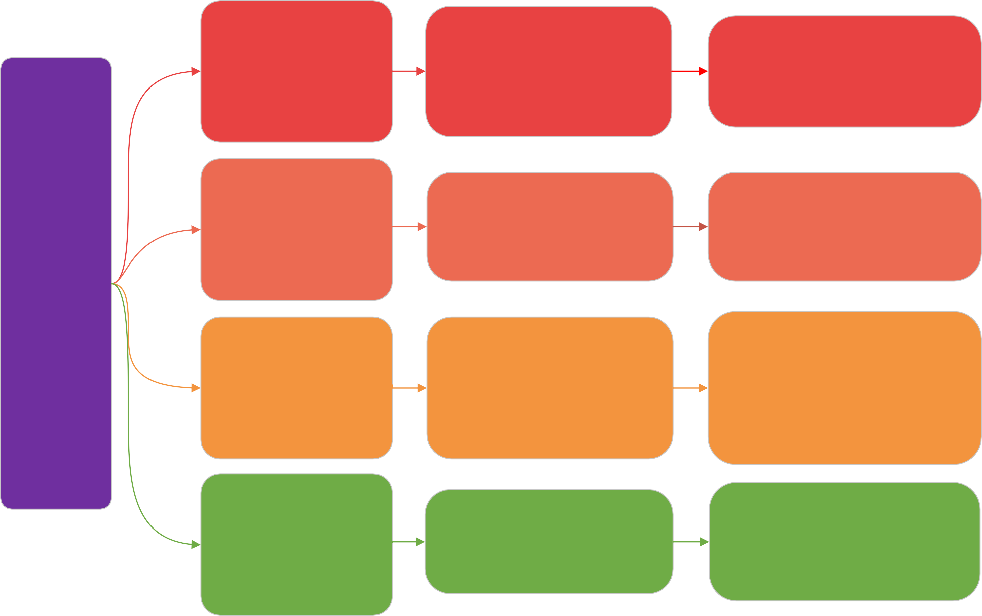**What this means What you should do**

There is an immediate concern for the

## Let's Talk Tool

+

## Continuum of Need Tool

+

## Effective Support for Children, Young People, and Families

**Level 4: Specialist** Children and young people supported by statutory and specialist agencies

**Level 3: Intensive** Children and young people with intensive needs and are supported by multiple services and a lead professional

**Level 2: Additional** Children and young people with additional needs receiving focused support from a professional

child's safety, and you will need to make a referral to North Somerset Children's Services Front door as soon as

possible. These referrals will be triaged within 24 hours by the duty social worker in the Front Door and a decision about next steps will be made

The child or young person is at significant risk of not achieving expected outcomes and requires a holistic and coordinated approach with more intensive intervention and help

A response from a professional or service needed to support health, educational, or social development. These are likely to be short term needs, but if ignored may

escalate and prevent them from achieving their full potential. The safeguarding lead or trusted person will lead at this level

You will need to contact the Front Door. Refer to the 'Requesting Support from Specialist Statutory Services or Children's Social Care'

in *Effective Support for Children, Young people, and Families*

You will need to seek consent from the family to make a referral to the most appropriate service/professional - the section on intensive

support in *Effective Support for Children, Young People, and Families* will guide you on what steps to take next

You should use the resources available to you to identify the needs of the family or child and create a plan for support so that concerns do not escalate. This could be through the tools in the Early Help Strategy, the guidance in the Effective Support document, or your own

resources. Professionals always have a

responsibility to check up on the plan later

**Level 1: Universal** Children and young people with no identified additional needs

The child should reach their fu ll potential through the support of their family and community. They should have access to good education and health services, secure housing, and not be at risk of abuse or neglect in the home or elsewhere

You can offer signposting and guidance to universal services in the local area. Check if the family are getting universal services and take appropriate action if not. You can continue to monitor the child/family in line with your professional judgement and usual practice standards

# North Somerset Early Help Planning Tool

**Housing and**

**finance**

**Education and**

**learning**

**Developmental, physical and mental health**

**Basic safety and**

**protection**

**If you have circled 3 or more supporting families criteria in the Let's Talk Tool, then contact the North Somerset Council Family Wellbeing Team**

**What progress has been made?**

Leave this column blank and then return

to it after a set amount of time has passed.

Has progress been made? What's changed? What else might we need to do?

**What are we going to do?**

This is where you record the actions that professionals will do to support the family with the things they're worried about.

1. **Insecure housing**
2. **Finanical**

**instability**

**8) At risk of not**

**getting a good**

**education**

**Needs support with:**

1. **Physical and**

**mental health**

1. **Meeting**

**developmental**

**milestones**

1. **At risk of**

**domestic abuse**

1. **Children at risk of abuse and exploitation**

**Needs support with:**

1. **Family**

**relationships**

1. **Substance misuse**
2. **Issues with crime**

**Supporting Families Outcomes**

Please circle any

that apply.

**How will we know things have improved?** What outcomes are we trying to achieve? What does 'good' look like for this child, young person or family?

**Family and environmental factors**