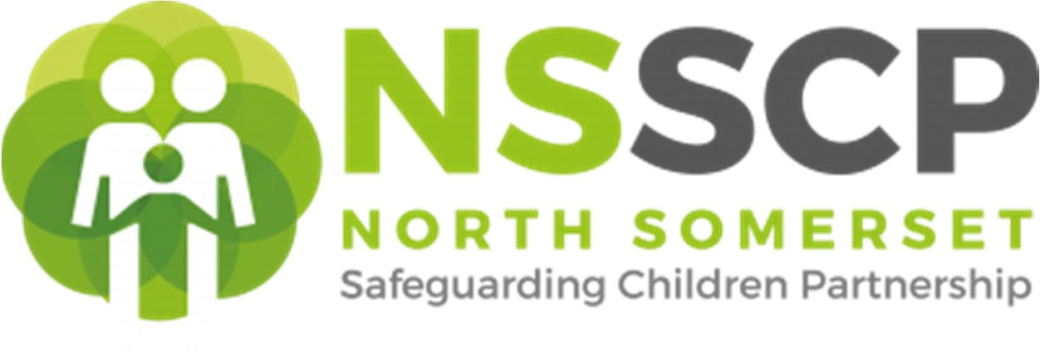

**Effective Support for Children, Young People, and Families in North Somerset**

**Appendix 3 – Types of Abuse and Vulnerable Status**

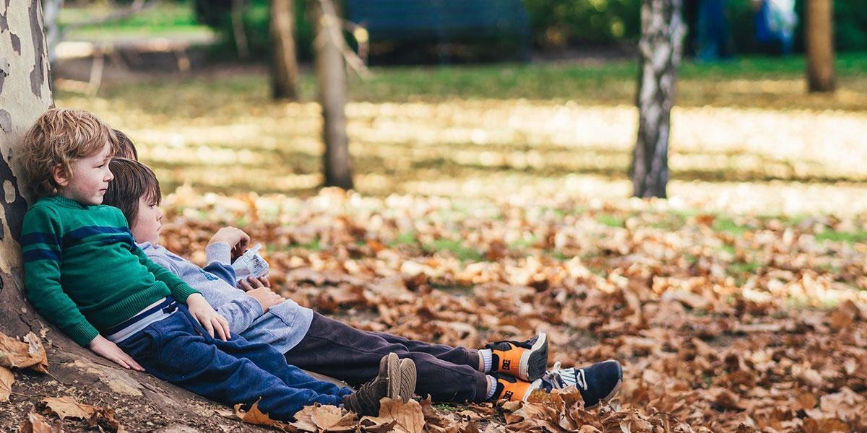

# ABUSE

Child abuse is more than bruises and broken bones. While physical abuse might be the most visible, other types of abuse can remain hidden. These include: emotional abuse, exploitation, and neglect. There are also so-called ‘hidden harms’ that can come from living with mental health, substance misuse, or domestic abuse.

The range of difficulties for those affected by parental difficulties varies and can include enduring stress and an unpredictable home environment. Sometimes violent experiences can become the norm in families. Moreover, children or young people who experience abuse in the home are now recognised as victims of abuse in their own right under the Domestic Abuse Act (2021) and should be appropriately assessed and supported.

# DOMESTIC ABUSE

Domestic abuse can affect anyone regardless of ethnicity, age, gender, sexuality, or social background. Domestic abuse is categorised by any incident or pattern of incidents of controlling, coercive, or threatening behaviour, violence or abuse between those aged 16 or over who are or have been intimate partners or family members regardless of gender or sexuality.

This definition includes honour-based abuse and forced marriage and is clear that victims are not confined to one gender or ethnic group.

# CHILD ON CHILD ABUSE (FORMERLY PEER-ON-PEER ABUSE)

Peer-on-peer/child-on-child abuse can be motivated by perceived differences e.g. on grounds of race, religion, gender, sexual orientation, disability or other differences. It can result in significant, long lasting and traumatic isolation, intimidation or violence to the victim. Children or young people who harm others may have additional or complex needs, e.g. significant disruption in their own lives, exposure to domestic abuse or witnessing or suffering abuse, educational under-achievement, being involved in crime. It should be recognised that child abuse is harmful to both the perpetrator (who is a child) and the victim.

# SEXUAL ABUSE

Sexual abuse includes rape, forced sexual acts, and sexual degradation. Any sexual act that involves force (including emotional blackmail) is abuse – this includes pestering, name calling, and threatening to get sex from ‘elsewhere’ in order to manipulate someone who does not want to have sex at that time into having sex. Sexually abusive relationships can include being forced to watch pornography as well as being forced into having sex with the perpetrator’s friends or into prostitution. Often people will question if it is rape if the couple are married. The answer is always yes. Rape is rape whether or not it is within a marriage. Rape and sexual abusive relationships are criminal regardless of the relationship between the perpetrator and the victim.

# NEGLECT

Neglect is the persistent failure to meet a child/young person’s basic physical and/or psychological needs. Neglect often causes a child serious impairment to their development and health.

Research indicates that the impact of neglect on children is cumulative, and that while short term neglectful parenting can be mitigated, chronic neglect has a clear physical and emotional impact on children. Long-term neglect must be recognised early and acted upon.

Neglect may even impact a developing foetus, causing later health issues. Neglect may involve a parent or carer failing to:

* Provide adequate food, clothing, and shelter (including exclusion from home or abandonment)
* Protect a child from physical and emotional harm or danger
* Ensure adequate supervision (including the use of inadequate caregivers)
* Ensure access to appropriate medical care or treatment
* Attend antenatal care appointments

The Neglect Toolkit is designed to assist professionals in identifying and assessing children and young people who are at risk of and experiencing neglect. It is to be used when professionals are concerned that the quality of care of a child/young person they are working with suggests that their needs are being neglected. For the Neglect Strategy and to download the Neglect Toolkit: https://[www.proceduresonline.com/swcpp/northsomerset/local_resources.html.](http://www.proceduresonline.com/swcpp/northsomerset/local_resources.html)

# HARMFUL SEXUAL BEHAVIOUR

All children and young people will enter a process of sexual development throughout their childhood and adolescence, and much of this will form a healthy and necessary part of growing up. However, for some, their behaviours will not be developmentally appropriate and, at times, may be harmful. The context of the behaviour, level of understanding, cultural and peer norms as well as the reaction of the perceived victims are all important factors to consider when assessing how concerned we should be about sexual behaviour displayed by children and young people.

# CONTEXTUAL SAFEGUARDING

Contextual safeguarding recognises that as young people grow and develop, they are influenced by a whole range of environments and people outside of their family. This could be in school or college, in the local community, sports clubs, peer and friendship groups and in online communities. Children and young people may experience risk in these places. There is no place where risk to children is impossible. Risks may be in more than one of these contexts, and they may be inter-related, causing multiple risks to the child’s welfare and wellbeing. Parents and carers have little influence over these contexts, and young people’s experiences of extra-familial abuse can undermine parent/child relationships.

Contextual safeguarding considers how to best understand these risks, how they change as children get older and their contexts change, and how to mitigate risk and keep children safe. Therefore, all who work to protect children from harm must engage with individuals and sectors who have influence over/within extra-familial contexts. All must recognise that the assessment of and intervention with these spaces are a critical part of safeguarding practices. Contextual safeguarding expands the expectations of child protection systems in recognition that young people are vulnerable to abuse beyond their front doors.

# RISKS OUTSIDE THE FAMILY (sometimes referred to as extra-familial harm)

Addressing Risks Outside the Family or home is an approach to understanding, and responding to, young people’s experiences of significant harm beyond their families. It recognises that the different relationships that young people form in their neighbourhoods, schools and online can feature violence and abuse. Parents and carers have little influence over these contexts, and young people’s experiences of extra-familial abuse can undermine parent/child relationships.

Practitioners should engage with individuals and sectors who do have influence within extrafamilial contexts, and recognise that assessment of, and intervention with, these spaces are a critical part of safeguarding practices. Risks outside the family or home therefore, expand the objectives of child protection systems in recognition that young people are vulnerable to abuse in a range of social contexts. For more on Risks Outside the Family - also known as Contextual Safeguarding.

# INTRAFAMILIAL ABUSE

Intrafamilial child abuse and/or neglect means the injury, sexual abuse, sexual exploitation, or negligent treatment or maltreatment of a child by any person under circumstances which indicate that the child's health, welfare, and safety is harmed thereby.

# MODERN DAY SLAVERY AND TRAFFICKING

Child trafficking is child abuse. It’s defined as recruiting, moving, receiving and harbouring children for the purpose of exploitation (HM Department for Education and Home Office, 2011). Child trafficking is a form of modern slavery (HM Government, 2014). Many children are trafficked into the UK from overseas, but children can also be trafficked from one part of the UK to another. Children are trafficked for:

* child sexual exploitation
* criminal activity, including:
  + cannabis cultivation
  + street crime such as:
    - pickpocketing
    - begging and bag theft
  + moving drugs
  + benefit fraud
  + immigration fraud
  + selling pirated goods, such as DVDs
* forced marriage
* illegal adoption
* unreported private fostering arrangements (for any exploitative purpose)
* domestic servitude, including:
  + cleaning
  + childcare
  + cooking
* forced labour, including working in:
  + restaurants
  + nail bars
  + factories
  + agriculture

This list is not exhaustive and children who are trafficked are often exploited in more than one way.

The National Referral Mechanism (NRM) is a framework for identifying victims of modern slavery and human trafficking and ensuring they

receive the appropriate protection and support. Comprehensive guidance and referral forms are on the GOV.uk website.

# CHILD EXPLOITATION

When assessing a child or young person’s vulnerability, exploitation should always be considered. The impact of exploitation on North Somerset’s communities has become much more prominent in the past few years and is now a major concern for all agencies. Often a hidden crime, it is crucial that practitioners understand the term ‘exploitation’ and how to apply this when working through a plan for effective support and protection.

Child sexual exploitationis when people use the power they have over young people to sexually abuse them. Their power may result from a difference in age, gender, intellect, strength, money, or other resources. People often think of child sexual exploitation in terms of serious organised crime, but it also covers abuse in relationships and may involve informal exchanges of sex for something a child wants or needs, such as accommodation, gifts, cigarettes, or attention. Some children are groomed through people who then force the child or young person into having sex with friends or associates.

Trafficking and criminal exploitationare forms of abuse and therefore should be afforded a safeguarding response. Often only visible symptoms of abuse receive a response, meaning that many children and young people receive a criminal justice response, while their safeguarding needs are overlooked.

Criminal exploitationinterlinks with a number of multiple vulnerabilities and offences, including the child or young person being exposed to, and/or being victim of, physical and emotional violence, neglect, sexual abuse and exploitation, modern day slavery, and human trafficking, domestic abuse and missing episodes.

The term ‘**County Lines’** is used to describe situations where children or young people may be recruited or transported by threats or coercion for the purpose of criminal exploitation. What is often less understood are the experiences a child or young person faces, and the potential for them to be harmed through various forms of abuse and exploitation as a result.

# DISGUISED COMPLIANCE

Disguised Compliance involves parents giving the appearance of co-operating with child welfare agencies to avoid raising suspicions and allay concerns. Published safeguarding case reviews highlight that professionals sometimes delay or avoid interventions due to parental disguised compliance.

At the most basic level, disguised compliance harms children as it prevents practitioners being able to assess the risks properly to children in the household. Babies and younger children can be particularly vulnerable, and the effects of missing out on timely safeguarding interventions can last throughout their childhood. Disguised Compliance also harms children in the following ways:

* Through missed opportunities to intervene
* By changing professional focus from children to the adults in the family, resulting in drift and delay
* By making practitioners feel overly optimistic about progress

# RADICALISATION AND EXTREMISM

Preventing vulnerable people from becoming drawn into terrorism is a key pillar of the National Counter Terrorism Strategy (CONTEST). It is about safeguarding children and adults, using existing and specialist tools to intervene early and prevent escalation into the ‘criminal space’ through a multi-agency Channel Panel.

Being radicalised is a form of exploitation and children and young people who are at risk are often at risk of other forms of exploitation because they are seeking acceptance, change or have experienced a grievance.

Knowing when a child presents early indicators of being drawn into terrorism can be tricky to spot and the need to take action can be daunting for practitioners. Signs that may indicate a child is being radicalised include:

* Isolating themselves from family and friends
* Talking as if from a scripted speech
* Unwillingness or inability to discuss their views
* A sudden disrespectful attitude towards others
* Increased levels of anger
* Increased secretiveness, especially around internet use

# EMOTIONAL WELLBEING AND MENTAL HEALTH

The emotional well-being of children is just as important as their physical health. Good mental health allows children and young people to develop the resilience to cope with whatever life presents them and grow into well-rounded, healthy adults. The antenatal period and early childhood is a time of particular importance, as children’s brains are quite literally shaped by their experiences. Abuse, insecurity, and anxiety in the early years can be hugely detrimental to a child’s development. Promoting good mental health and wellbeing is the first building block to building emotional resilience to help with such challenging life events.

Things that can help promote emotional wellbeing in children and young people include:

* Being in good physical health, eating a balanced diet and getting regular exercise
* Having time and the freedom to play, indoors and outdoors
* Being part of a family that gets along well most of the time
* Going to a school that looks after the well-being of all its pupils
* Taking part in local activities for young people.

Other factors are also important, including:

* Feeling loved, trusted, understood, valued and safe
* Being interested in life and having opportunities to enjoy themselves
* Being hopeful and optimistic
* Being able to learn and having opportunities to succeed
* Accepting who they are and recognising what they are good at
* Having a sense of belonging in their family, school and community
* Feeling they have some control over their own life
* Having the strength to cope when something is wrong (resilience) and the ability to solve problems

# SELF-HARM

Self-Harm is usually a way of coping with or expressing overwhelming emotional distress. It is usually done when something else is wrong and it seems like the only way to let those feelings out. The most common triggers include:

* Alcohol and/or drug misuse
* Anxiety
* Bullying
* Sexual, physical or emotional abuse
* Bereavement
* Exam pressure and school/parental expectations
* Confusion about sexuality
* Parents separation/divorce
* Health problems
* Relationships
* Low self-esteem
* Pressure from social media

There are myriad ways in which someone can injure themselves. For example: cutting, scratching, pinching, biting, pulling hair out, overdosing, and ingesting toxic substances.

If someone is self-harming it is very important to try and understand what is causing them distress. Young people especially may need a lot of help to develop skills to cope with more stressful and traumatic situations in a less harmful way.

Any child or young person who expresses thoughts about suicide must be taken seriously, and appropriate help and intervention should be offered at the earliest point. Any practitioner, who is made aware that a child or young person has self-injured, or is contemplating this or suicide, should talk with the child or young person without delay.

# PRE-BIRTH

Pregnancy and birth of a baby is a critical window of opportunity when parents are especially receptive to offers of advice and support. Young babies are particularly vulnerable to abuse, therefore, work carried out in the antenatal period can help prevent and/or minimise any potential harm if there is early assessment, intervention, and support.

All professionals have a role in identifying and assessing families in need of additional support or where there are safeguarding concerns. Where professionals become aware a woman is pregnant, at whatever age of the pregnancy and they have concerns for the mother or the unborn baby’s welfare, or that of siblings, they must not assume that Midwifery or other Health services are aware of the pregnancy, or the concerns held. Each professional should follow the South West Child Protection Procedures pre-birth protocol, their agency’s child protection procedures, and discuss concerns with their safeguarding lead/named practitioner for safeguarding.

# YOUNG CARERS

Young carers are children and young people who look after someone in their family who has a disability, a long-term illness, or is affected by mental ill health or substance misuse. Young carers may look after parents/carers, care for a sibling, or other relative. Their caring responsibilities can vary but can include:

* Helping around the house
* Looking after siblings
* Managing money
* Supporting with medication
* Personal care
* Organising and coordinating
* Communication assistance
* Emotional care and support

Many children and young people may take on age-appropriate responsibilities in their families; the identity of a young carer is exclusive to those children and young people taking on additional responsibilities, beyond what you would expect for their age or specific to the cared for person’s needs. Providing care can have an impact on children and young people – positively, they can gain new skills, become mature beyond their years, and demonstrate their care for their family.

At times, particularly when caring responsibilities become inappropriate or excessive, these responsibilities can have an impact on their mental/physical health, educational attainment, and attendance, cause social isolation and have long term socio-economic impact causing them not to meet their full potential.

To ensure young carers can access appropriate support, with consent, complete an Early Help Assessment so they can access a Young Carers Assessment.

# SPECIAL EDUCATIONAL NEEDS AND DISABILITIES (SEND)

Children and young people with SEND have learning difficulties or disabilities that make it harder for them to learn than most children and young people of the same age. These children and young people may need extra or different help from that given to others.

Many children and young people will have SEND of some kind at some time during their education. Early years providers (for example, nurseries or childminders), mainstream schools, colleges and other organisations can help most children and young people succeed with some changes to their practice or additional support. However, some children and young people will need extra help for some or all of their time in education and training.

Children and young people with SEND may need extra help because of a range of needs. Paragraphs 6.27 – 6.35 of the 0-25 SEND Code of Practice set out four areas of SEND:

1. Communicating and interacting
2. Cognition and learning
3. Social, emotional, and mental health difficulties
4. Sensory and/or physical needs

Details of the North Somerset Local Offer for SEND.

# ALLEGATIONS MANAGEMENT

If there is a concern in relation to an employee or volunteer who is alleged to have:

* + Behaved in a way that has harmed a child, or may have harmed a child
  + Possibly committed a criminal offence against or related to a child
  + Behaved towards a child or children in a way that indicates they may pose a risk of harm to children

You will need to follow your own agency processes and report any concern to the Local Authority Designated Officer (LADO) 01275 888211. The Referrer must ensure that a record of the referral is retained in the organisation.